BREAKING NEWS
Newsletter
Issue 5 January/February 2017
President’s note:
Greetings Federation Family,
2017 has been a busy year already for NFBF. The affiliate presidents had a great retreat just prior to Washington seminar. We had a parent attend the parent learning program just prior to Washington Seminar. We had a great team of delegates on the hill for Washington Seminar. The NFBF board had a great meeting with members of NFBF Central Florida Chapter to plan our 2017 state convention. Please mark your calendars to attend. Thank you to all that are participating actively in the federation. I look forward to our family being together in May!
Remember we want your tips, stories, recipes, chapter activities, here in the Newsletter.
Find us on twitter and FB @nfbflorida.
Denise Valkema, President NFB OF Florida
president@nfbflorida.org
Facebook & Twitter @nfbflorida
We are filled with hope, energy and love by participating in the National Federation of the Blind. Every day we work together to help blind people live the lives they want.

Announcements and Comments:
New Chapter Officers
Reminder to send list of new officer’s names to the president and secretary so we can update our website and records. Thank you for your cooperation.

NOW YOU CAN SCHEDULE RIDES WITH UBER
Sometimes you want to schedule a pickup in advance so you can rest assured an Uber will be available when you need it, especially if it’s for a 4am ride to the airport. With Scheduled Rides you can request your Uber 30 days to 15 minutes ahead of time and have the comfort of knowing your Uber will be there when it's time to head out. See below for additional terms and information.
How it works to Schedule a ride: 1. Choose your ride and tap "Schedule a Ride" to request up to 30 days in advance. 2 Set pickup info. Set your pickup date, time, location, and destination, and get a fare estimate. 3 Confirm your trip. Confirm the details of your upcoming trip and tap Schedule. You can edit or cancel at any time before your ride is ready. 4 Enjoy your ride. We’ll send you reminders the day of the trip and notify you when your ride is on the way. We’ll also let you know if surge pricing applies.

SHOP SMILE.AMAZON.COM
Start with a smile and shop smile.amazon.com and select NFBF as charity of choice. NFBF will benefit at no additional cost to you. Nothing changes, just use your regular sign on and password and shop as usual. NFBF will reap the rewards by you doing the what you usually do. Happy shopping! AmazonSmile: You shop. Amazon gives.

Birthdays & Celebrations:
The NFBF would like to celebrate:
Birthdays:
January:
Bowman, Jackie, Tallahassee
Tyrone McCleod, Tallahassee

February:
Lisa Johnson, Tallahassee

Anniversaries:

NFBF Calendar:
Convention Events Planning committee: February 8, 2107 at 8pm by teleconference
Empowerment committee meeting: January 23, 2017 at 8:30 pm by teleconference
411 Interest Topic Call: March 12, 2017 at 8pm Topic: NFB Philosophy
Newsline Committee meeting: TBA
Presidents & Vice Presidents Committee meeting: February 12, 2017 at 7pm by teleconference
Senior Committee meeting: February 5, 2017 at 7pm by teleconference
State Board Meeting: February 5, 2017 meeting in Orlando and February 27th by teleconference
2017 State Convention: May 26-29, 2017 at the Doubletree by Hilton Downtown Orlando

Legislative Updates:
Washington Seminar
The decent upon the Capital was awesome and very successful. We received good news that the Marrakesh Treaty may soon be ratified by the Senate. We have cosponsors for the Access Technology Affordability Act by Congressman David Young of Iowa and Congressman Gus Bilirakis of Florida. And also we received positive interest for AIM HE and the Appropriation to the National Library Service for the Blind and Physically Handicapped (NLS) for the Purchase of Refreshable Braille Devices. Watch for details on the seminar soon. See pictures in the photo gallery.

Technology: Tips & Tricks
KNFB Reader wants you to make the print yours and expand your horizons. KNFB Reader is a mobile app that reads print aloud. It's easy to use: take a photo and the app reads the text aloud in clear synthetic speech. And it's fast: the print will be yours almost instantly. The app is fully accessible thanks to Voiceover, Google TalkBack, and app functionalities that guide the blind user in independently taking the perfect picture. The app can currently recognize text in nineteen different languages and is compatible with connected Braille displays. To buy KNFB Reader visit www.knfbreader.com or visit the App Store or the Google Play Store. If you would like a demonstration or instruction contact Jorge Hernandez at Phone: 305-877-2311 or Email: jeh1065@comcast.net.

Inspiration Conner:
“One day we must come to see that peace is not merely a distant goal we seek, but that it is a means by which we arrive at that goal. We must pursue peaceful ends through peaceful means.” – Dr. Martin Luther King Jr.

Chapter, Division, and Committee updates:
Greater Broward Chapter: Tom Ryan, President; Phone: 954-442-1855, Email Ryantom@bellsouth.net.

Central Florida Chapter: Sherri Brun, President; Please like us on Facebook at: https://www.facebook.com/groups/410985858949160. We meet the third Saturday of each month from 11:00am to 1:00pm at Lighthouse Central Florida, 215 East New Hampshire Street, Orlando, Florida 32804.

Greater Daytona Beach Chapter: Scott Larson, President; Phone: 386-235-0565; Email: Blindscotty@samobile.net. We meet the fourth Saturday of the month 11:30am to 1:30pm at TGI Friday's, 24 Ocean Shore Blvd., Ormond Beach FL 32176. Follow Us on Facebook: www.facebook.com/nfbdaytona.

Gainesville Chapter: Judith Hamilton, President; Phone: 352-373-7806, Email: gainesville_nfb@earthlink.net. The Gainesville Chapter welcomes you to our monthly chapter meetings. Our meetings are held the second Saturday of each month from 2:00PM to 4:00PM, with meet and greet at 1:00PM. We meet at the Northwest Grille, 5115 Northwest 39TH Avenue, Gainesville, Florida. Because the fall brings college football to our town, scheduled meetings sometimes require adjustment. Restaurants get booked and traffic is re-routed during home games at the University of Florida. For additional meeting information/updates, please contact Judy Hamilton, Chapter President.

Greater Jacksonville Chapter: Marita Winston, President; Phone: 904-323–8597, Email: marita.winston60@gmail.com. We are planning a yard sale March 18 and a pancake breakfast at Applebee’s May 6, 2017. Please join us if you are in the area.

Greater Miami Dade Chapter Jorge Hernandez – President; Phone: 305-877-2311; Email: jeh1065@comcast.net. Our meetings are held on the third Thursday of each month. Location: Denny's Restaurant, 5825 N. W. 36 Street, Miami, FL.

Palm Beach Chapter: Tekesha Saffold, President; 561-707-4799; Email: tnsaffold82@gmail.com. We have monthly meetings on the Second Saturday of every month at 4746 North Congress Avenue, Boynton Beach, FL 33425.

Pinellas Chapter: Larry Ball; President; Phone: 727-614-9134; Email: lball42@tampabay.rr.com. Our meetings are held on the third Saturday of the month at Applebee’s, 5110 E Bay Drive in Largo. We meet for lunch at noon and the business meeting starts at 1:00pm. We are working hard to change what it means to be blind in Pinellas county.

Polk Chapter: Joe King, President: Phone: 863-293-5648; Email: joenkitty@earthlink.net. Our meetings are held the second Saturday of the month at: Winter Haven Manor, 140 Avenue A S.W., Winter Haven, Florida, at 10:00am-12:00pm.

Space Coast Chapter: Joe Naulty, President; Facebook: www.brevard-nfb.org www.facebook.com/nfbmelbourne.

FL State Wide Chapter: Paul Martinez, President; Phone: 813-390-5720; Email: nfbf.statewide@gmail.com. The State-Wide Chapter invites you to join us on our conference call on the third Sunday of every month at 8:00pm. This chapter was designed for those who do not have a local chapter or for some reason cannot get to their local chapter for any given reason.

Suncoast Chapter: Lauren Blum, President; Phone: 352-584-0795; Email: nfbf.suncoast@gmail.com. We meet on the third Saturday of each month at IHOP, 363660 Commercial Way (US 19), Spring Hill, FL 34606.

Tallahassee Chapter: Jada Christie, President; Phone: 850-766-9378 Email: emeraldpink15@gmail.com. We meet the 1st Monday of each month and the Lighthouse of the Big Bend, Tallahassee, FL 32303. Congratulations to our newly elected 2017 board. Join us, if you are in the area. We are celebrating Valentine’s Day with a raffle for a basket of items for the romantic valued over $400.

Tampa Chapter: Miranda Kilby, President; Phone: 352-942-0417; Email: NFBF.Tampa@gmail.com. Join us the fourth Saturday of every month.

Treasure Coast Chapter: Tim Edwards, President; Phone: 630-432-5090; Email: tred34990@gmail.com. We serve the following counties: Martin, St. Lucie, Indian River & Okeechobee. Come join the Treasure Coast Chapter of National Federation of the Blind for its monthly meeting on the 2nd Saturday of each month from 10am till noon. Mark your calendar for the following guest speakers: February 10th-Lighthouse for the Blind (tentative); March 10th-Elections- KNFB reader- NFB tool kit; April 14th-Dr. Timothy Schoen, Foundation Fighting Blindness.

Florida Association of Guide Dog Users (FLAGDU): Sherrill O'Brien, Division President; flagdu@nfbflorida.org

Deaf-Blind Division: Julia Savage, President; Email: Nfb.florida.deafblind@gmail.com. The FL Deaf-Blind division meets on the first Tuesday of every month at 8:00pm. If you are interested in attending this meeting and learning what the division has; please contact the president.

Florida Organization of Parents of Blind Children (FOPBC): The Parents Division is being reorganized by Kimberly Banks, Email: kimberlybanks1984@gmail.com

Florida Association of Blind Students: The FABS invites any high school or college student to attend our conference calls on the third Sunday of every month at 6:00pm. For further information, contact the president, Paul Martinez at nfbfabs@gmail.com To call into our meetings use conference number 641-715-324 and access code 401665.

The National Association of Blind Veterans: Dwight Sayer, President; 321-948-1466; Email: president@nabv.org; PO Box 784957, Winter Garden, Florida 34778.

Photo Gallery:
Pictures from the Washington Seminar:
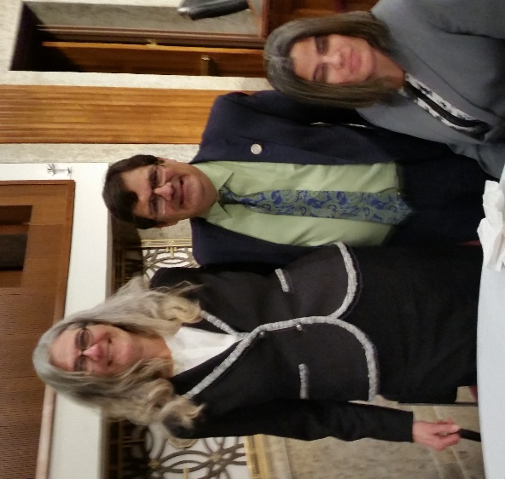
Merry Schoch, Congressman Bilirakis and Jeanett Torres

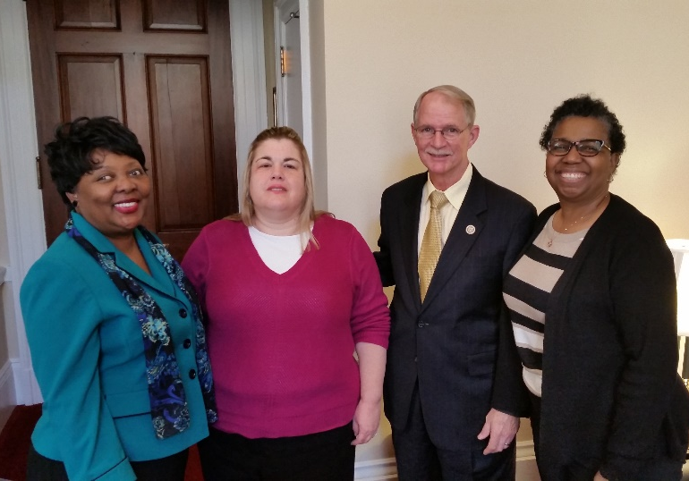
Jada Christie, Kaye Zimpher, Congressman Rutherford and Sylvia Young

Sylvia Young, Congressman Lawson, Jada Christie and Kaye Zimpher

Please contact any of the board with questions, comments, concerns or for general information.
NFBF Board of Director’s Information:
Denise Valkema -President
Phone: 305-972-8529
Email: president@nfbflorida.org

Paul Martinez - 1st Vice President
Phone: 813- 390-5720
Email: paul09ms@gmail.com

Miranda Kilby – 2nd Vice President
Phone: 352- 942-0417
Email: mbkilby@gmail.com

Sylvia Young-Secretary
Phone: 850- 322-5937
Email: secretary@nfbflorida.org@nfbflorida.orgtary@nfbflorida.org

Gloria Mills –Treasurer
Phone: 813-340-9754
Email: glorianfbf@gmail.comglorianfbf@gmail.comlorianfbf@gmail.com

Board Members:
Jorge Hernandez
Phone: 305-877-2311
Email: jeh1065@comcast.net

Tekesha Saffold
Phone: 561-707-4799
Email: tnsaffold82@gmail.com

Rafael Fernandez
Phone: 305-903-6299
Email: rafael.fernandez0617@gmail.com

Editor: Sylvia Young
To have something posted in the NFBF Newsletter please submit it to the editor, Sylvia young at secretary@nfbflorida.org by the 15th of each odd month.

