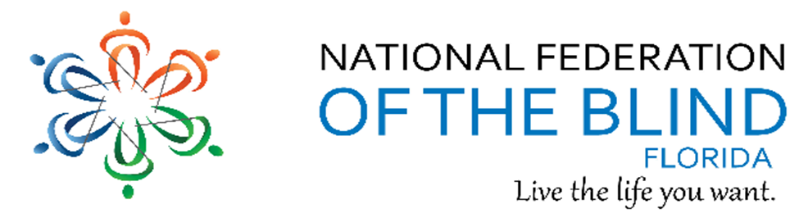
BREAKING NEWS
Newsletter
Issue 4 November/December 2016
President’s note:
Greetings Federation Family,
After the holiday season, we will begin 2017 with Washington seminar and months of preparation for our 2017 NFBF state convention. We encourage our members to participate in the planning and all we are doing to build the federation in Florida.
Wishing you a happy holiday,
Denise Valkema, President NFB OF Florida
president@nfbflorida.org
Facebook & Twitter @nfbflorida
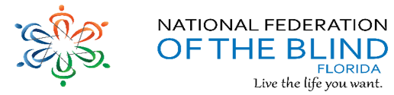
We are filled with hope, energy and love by participating in the National Federation of the Blind. Every day we work together to help blind people live the lives they want.

Announcements and Comments:
New Chapter Officers
Since many chapters will be electing new officers in the next few months; this is a reminder to send those new officer’s names to the President and secretary so they can be updated on the website and our records. Thank you for your cooperation.

The Daily Winner Calendar Raffle is Here!
We had an awesome Raffle with winners all over the state. Congratulations for all the winners both individual and chapters.

SHOP SMILE.AMAZON.COM
Start with a smile and shop smile.amazon.com and select NFBF as charity of choice. NFBF will benefit at no additional cost to you. Nothing changes, just use your regular sign on and password and shop as usual. NFBF will reap the rewards by you doing the what you usually do. Happy shopping! AmazonSmile: You shop. Amazon gives.

Birthdays & Celebrations:
The NFBF would like to celebrate:
Birthdays:
November:
Jeffery Davis - Tallahassee
Judy Hamilton - Gainesville
Carol Massey- Gainesville
Joan Miles – Gainesville

December:
Jada Christie - Tallahassee
Sylvia Young - Tallahassee

Anniversaries:

NFBF Calendar:
Convention Planning committee: TBA
Empowerment committee meeting: December 5, 2016 at 8:30 pm by teleconference
411 Interest Topic Call: January 8, 2017 at 8pm by teleconference exact date TBA
Newsline Committee meeting: TBA
Presidents & Vice Presidents Committee meeting: December 11, 2016 at 7pm by teleconference
Senior Committee meeting: No meeting in December
State Board Meeting: Tuesday, December 27, 2016 at 7pm by teleconference
Washington Seminar: January 30, through Thursday, February 2, 2017
2017 State Convention: May 26-29, 2017 at the Doubletree by Hilton Downtown Orlando

Legislative Updates:
Washington Seminar
We will be descending upon the Capital of this great country beginning Monday, January 30, 2017. Those that are going will be busy about educating and encouraging support for the TIME Act. Wish them safe travels and success. Applications must be submitted by December 1, 2016

Legislative action needed says Parnell.
On this last day of November, I have the following matters to bring to your attention. First, please take a moment to call your House member this week and ask her or him to cosponsor the Accessible Instructional Materials in Higher Education (AIM HE) Act., H.R. 6122. AIM HE was introduced by Republican Phil Roe of Tennessee, and the lead cosponsor is Democrat Joe Courtney of Connecticut. You can reach the Capitol Switchboard at (202) 224-3121. From there, simply request to be connected with your Congressman.
While on the phone, please also mention the TIME Act, H.R. 188. Below this message, I am listing the names of each House member of Florida as acknowledgement to those which have secured cosponsors on the TIME Act during the 114th Congress. There are seventy-eight of them to date. Please thank your representative if she or he has cosponsored the TIME Act, or urge them to do so in addition to cosponsoring AIM HE. Your calls are important because it is crucial that we stay in contact with our legislators on a regular basis, moreover, while the 114th Congress is about to come to an end, gaining these cosponsors will help us get off to a quicker start in the next Congress.
TIME Act (H.R. 188)
Bilirakis, Gus M. [R-FL-12]
Castor, Kathy [D-FL-14]
Grayson, Alan [D-FL-9]
Hastings, Alcee [D-FL]

Technology: Tips & Tricks
KNFB Reader wants you to make the print yours and expand your horizons. KNFB Reader is a mobile app that reads print aloud. It's easy to use: take a photo and the app reads the text aloud in clear synthetic speech. And it's fast: the print will be yours almost instantly. The app is fully accessible thanks to Voiceover, Google TalkBack, and app functionalities that guide the blind user in independently taking the perfect picture. The app can currently recognize text in nineteen different languages and is compatible with connected Braille displays. To buy KNFB Reader visit www.knfbreader.com or visit the App Store or the Google Play Store. If you would like a demonstration or instruction contact Jorge Hernandez at Phone: 305-877-2311 or Email: jeh1065@comcast.net.

NFB-NEWSLINE has expanded with a dozen new publications! Additions as follows: 1.Athlon Sports (magazine) 2. Bon Appetit (magazine) 3. Brides (magazine) 4. Capital Gazette (Maryland) 5. Car and Driver (magazine) 6. Consumer Reports (magazine) 7. Discover (magazine) 8.GQ (magazine) 9. Information Week (magazine) 10. MIT Tech Review (magazine) 11. Prevention (magazine) 12. Spry Living (magazine)

Inspiration Conner:
“Challenges are what make life interesting and overcoming them is what makes life meaningful.” – Joshua J. Marine

Chapter, Division, and Committee updates:
Greater Broward Chapter: Tom Ryan, President; Phone: 954-442-1855, Email Ryantom@bellsouth.net.

Central Florida Chapter: Sherri Brun, President; Please like us on Facebook at: https://www.facebook.com/groups/410985858949160. We meet the third Saturday of each month from 11:00am to 1:00pm at Lighthouse Central Florida, 215 East New Hampshire Street, Orlando, Florida 32804.

Greater Daytona Beach Chapter: Scott Larson, President; Phone: 386-235-0565; Email: Blindscotty@samobile.net. We meet the fourth Saturday of the month 11:30am to 1:30pm at TGI Friday's, 24 Ocean Shore Blvd., Ormond Beach FL 32176. Follow Us on Facebook: www.facebook.com/nfbdaytona.

Gainesville Chapter: Judith Hamilton, President; Phone: 352-373-7806, Email: gainesville_nfb@earthlink.net. The Gainesville Chapter welcomes you to our monthly chapter meetings. Our meetings are held the second Saturday of each month from 2:00PM to 4:00PM, with meet and greet at 1:00PM. We meet at the Northwest Grille, 5115 Northwest 39TH Avenue, Gainesville, Florida. Because the fall brings college football to our town, scheduled meetings sometimes require adjustment. Restaurants get booked and traffic is re-routed during home games at the University of Florida. For additional meeting information/updates, please contact Judy Hamilton, Chapter President. The Gainesville Chapter accepted a proclamation from the City of Gainesville on October 20, 2016 recognizing “Meet the Blind Month.” On October 25, 2016, the Alachua County Board of County Commissioners presented a proclamation recognizing “Meet the Blind Month” to Judy Hamilton and Kathy Roskos. David Roskos was also present in the audience. Barry Greenberg, photographer from Hospice of the Nature Coast provided the pictures.

Greater Jacksonville Chapter: Marita Winston, President; Phone: 904-323–8597, Email: marita.winston60@gmail.com. We are also planning a vision expo for January 2017. Look for more information soon.

Greater Miami Dade Chapter Jorge Hernandez – President; Phone: 305-877-2311; Email: jeh1065@comcast.net. Our meetings are held on the third Thursday of each month. Location: Denny's Restaurant, 5825 N. W. 36 Street, Miami, FL. Congratulations to new officers Jorge Hernandez – President, John Johnson - Vice President, Ross Levine - board member.

Palm Beach Chapter: Tekesha Saffold, President; 561-707-4799; Email: tnsaffold82@gmail.com. We have monthly meetings on the Second Saturday of every month at 4746 North Congress Avenue, Boynton Beach, FL 33425.

Pinellas Chapter: Larry Ball; President; Phone: 727-614-9134; Email: lball42@tampabay.rr.com. Our meetings are held on the third Saturday of the month at Applebee’s, 5110 E Bay Drive in Largo. We meet for lunch at noon and the business meeting starts at 1:00pm. We are working hard to change what it means to be blind in Pinellas county.

Polk Chapter: Joe King, President: Phone: 863-293-5648; Email: joenkitty@earthlink.net. Our meetings are held the second Saturday of the month at: Winter Haven Manor, 140 Avenue A S.W., Winter Haven, Florida, at 10:00am-12:00pm.

Space Coast Chapter: Joe Naulty, President; Facebook: www.brevard-nfb.org www.facebook.com/nfbmelbourne.

FL State Wide Chapter: Paul Martinez, President; Phone: 813-390-5720; Email: nfbf.statewide@gmail.com. The State-Wide Chapter invites you to join us on our conference call on the third Sunday of every month at 8:00pm. This chapter was designed for those who do not have a local chapter or for some reason cannot get to their local chapter for any given reason.

Suncoast Chapter: Lauren Blum, President; Phone: 352-584-0795; Email: nfbf.suncoast@gmail.com. We meet on the third Saturday of each month at IHOP, 363660 Commercial Way (US 19), Spring Hill, FL 34606.

Tallahassee Chapter: Jada Christie, President; Phone: 850-766-9378 Email: emeraldpink15@gmail.com. We meet the 1st Monday of each month and the Lighthouse of the Big Bend, Tallahassee, FL 32303. Congratulations to Donald Christie for winning the Paula Bailey Award at the Lighthouse of the Big Bend Annual Dining in the Dark event in October. Annual officer elections during January 2017 meeting. Join us, if you are in the area.

Tampa Chapter: Miranda Kilby, President; Phone: 352-942-0417; Email: NFBF.Tampa@gmail.com. The Tampa chapter was excited to see all the wonderful winners during our daily calendar raffle. In the month of December, we are hosting a Christmas party on December 10, and invite anyone who is in the area to join us the fourth Saturday of every month.

Treasure Coast Chapter: Tim Edwards, President; Phone: 630-432-5090; Email: tred34990@gmail.com. We serve the following counties: Martin, St. Lucie, Indian River & Okeechobee. Come join the Treasure Coast Chapter of National Federation of the Blind for its monthly meeting on Saturday December 10th, 2016 from 10am till noon, at WQCS Radio Station @ IRSC, 3209 Virginia Avenue, Fort Pierce. Our guest speaker this month will be Horst W. Mueller. Horst will be teaching us ways to make our own Artistic, 3-Dimensional piece of Art. You can find Horst W. Mueller on the internet under “Even Hands can see”. Please note, there will be a 10.00 fee. This fee is for materials. We will also be hosting our annual Christmas party. Please RSVP to Tim Edwards, President of the Treasure Coast Chapter. Mark your calendar for the following guest speakers: January 13th-Ron Van Gelderen Lion Club; February 10th-Lighthouse for the Blind (tentative); March 10th-Elections- KNFB reader- NFB tool kit; April 14th-Dr. Timothy Schoen Foundation Fighting Blindness

Florida Association of Guide Dog Users (FLAGDU): Sherrill O'Brien, Division President; flagdu@nfbflorida.org

Deaf-Blind Division: Julia Savage, President; Email: Nfb.florida.deafblind@gmail.com. The FL Deaf-Blind division meets on the first Tuesday of every month at 8:00pm. If you are interested in attending this meeting and learning what the division has; please contact the president.

Florida Organization of Parents of Blind Children (FOPBC): The Parents Division is being reorganized by Kimberly Banks, Email: kimberlybanks1984@gmail.com

Florida Association of Blind Students: The FABS invites any high school or college student to attend our conference calls on the third Sunday of every month at 6:00pm. For further information, contact the president, Paul Martinez at nfbfabs@gmail.com To call into our meetings use conference number 641-715-324 and access code 401665.

The National Association of Blind Veterans: Dwight Sayer, President; 321-948-1466; Email: president@nabv.org; PO Box 784957, Winter Garden, Florida 34778.

Photo Gallery:
Meet the Blind Activity in Tampa
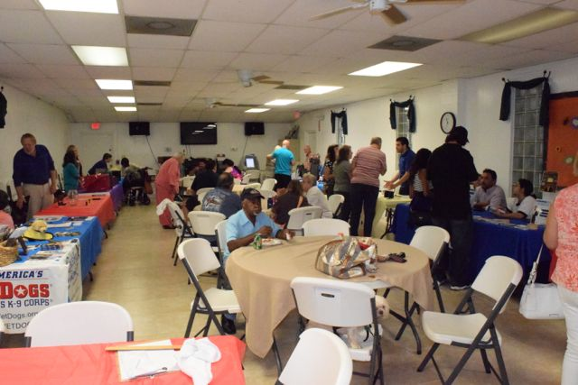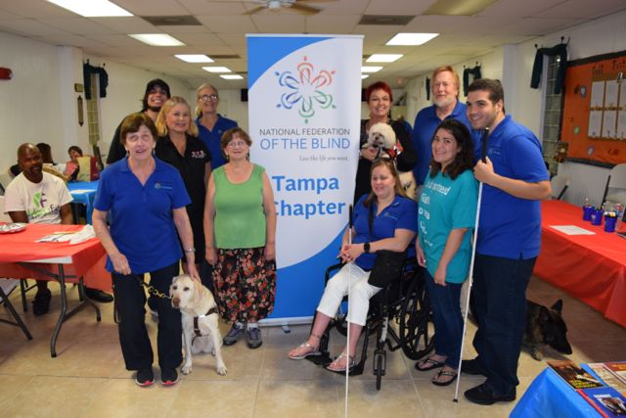
Annual Thanksgiving Awards Dinner in Tallahassee
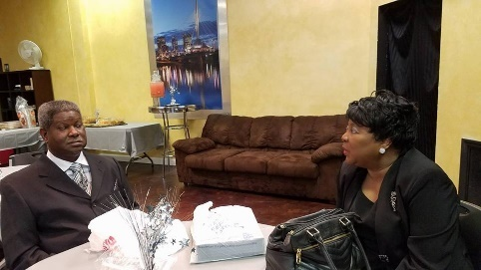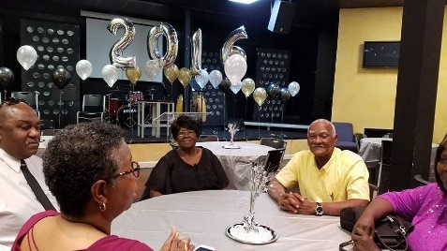
Donald Christie wins the Paula Bailey Award at the Lighthouse of the Big Bend’s Dining in the Dark October 2016
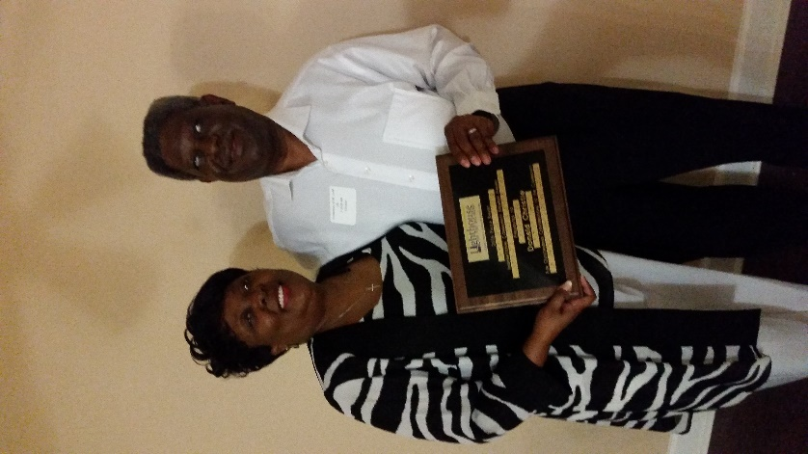
On October 25, 2016, the Alachua County Board of County Commissioners presented a proclamation recognizing “Meet the Blind Month” to Judy Hamilton and Kathy Roskos. David Roskos was also present in the audience. Barry Greenberg, photographer from Hospice of the Nature Coast provided the pictures.
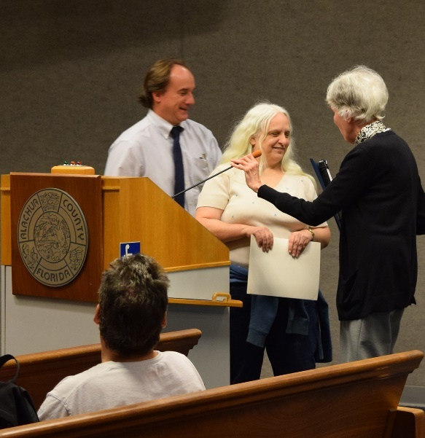

Please contact any of the board with questions, comments, concerns or for general information.
NFBF Board of Director’s Information:
Denise Valkema -President
Phone: 305-972-8529
Email: president@nfbflorida.org

Paul Martinez - 1st Vice President
Phone: 813- 390-5720
Email: paul09ms@gmail.com

Miranda Kilby – 2nd Vice President
Phone: 352- 942-0417
Email: mbkilby@gmail.com

Sylvia Young-Secretary
Phone: 850- 322-5937
Email: secretary@nfbflorida.org@nfbflorida.orgtary@nfbflorida.org

Gloria Mills –Treasurer
Phone: 813-340-9754
Email: glorianfbf@gmail.comglorianfbf@gmail.comlorianfbf@gmail.com

Board Members:
Jorge Hernandez
Phone: 305-877-2311
Email: jeh1065@comcast.net

Tekesha Saffold
Phone: 561-707-4799
Email: tnsaffold82@gmail.com

Rafael Fernandez
Phone: 305-903-6299
Email: rafael.fernandez0617@gmail.com

Editor: Sylvia Young
To have something posted in the NFBF Newsletter please submit it to the editor, Sylvia young at secretary@nfbflorida.org by the 15th of each odd month.

