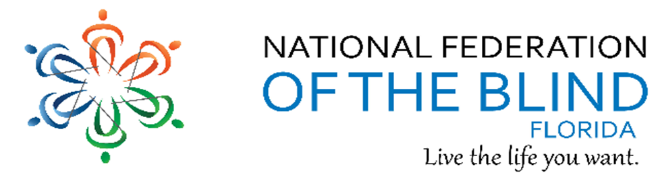BREAKING NEWS
Newsletter
Issue 9 September/October 2017
President’s note:
Greetings Federation Family,
We are grateful to our federation family, hearing from President Riccobono and other states for reaching out to our Florida federation family to offer support and check on us before and after Irma. I enjoyed hearing from our chapter presidents that our members seemed to have survived with minimal damage. Our thoughts are with our family in Puerto Rico and Texas.
Now that summer is over, we are ready for a busy schedule with Meet the Blind Month coming up, Washington seminar in January, and beginning to plan for our state convention over Memorial Day weekend 2018.
We encourage everyone to get involved doing something to build the federation. Feel free to reach out to your chapter president and members of the state board, including me, for ideas. Let us know if you have ideas, comments, concerns, and solutions. We want everyone to participate actively and be included.
Sincerely, Denise Valkema, President NFBF
Remember we want your tips, stories, recipes, chapter activities, here in the Newsletter.
Find us on twitter and FB @nfbflorida.
Denise Valkema, President NFB OF Florida
president@nfbflorida.org
Facebook & Twitter @nfbflorida
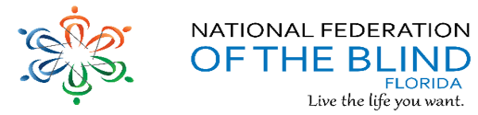
We are filled with hope, energy and love by participating in the National Federation of the Blind. Every day we work together to help blind people live the lives they want.

Birthdays & Celebrations:
The NFBF would like to celebrate:
Birthdays:
September:
Lorraine Clement – Miami
Marion Debusk – Gainesville
Judy Hamilton – Gainesville
Rose Haynes – Miami
Ross Livine – Miami
Willie Lucas – Miami
Denise Valkima – Miami
Violet Whittaker – Miami
John Williams – Miami
October:
Jorge Hernandez – Miami
Lenora McGowan – Gainesville
Tom Ryan - Broward
David Roskos – Gainesville
Anniversaries:
Sylvia and James Young – October, Tallahassee

NFBF Calendar: You can also find important dates on our Webpage
Senior Concerns: Thursday, October 5, at 8:00 PM. Number 712-775-7031, Code 488500#
President’s Committee: Sunday, October 8, 2017@ 7pm
Legislative Committee: Wednesday, October 18th, at 7 p.m. Number 712) 775-7031; Code 938047311#
State Board: Saturday, October 28, 2017, in Tampa, FL
NFB411 Call: November 12, 2017 at 7pm
Communication Committee: TBA
Empowerment Committee: TBA
NewsLine Committee: TBA

Announcements and Comments:
The Holiday Calendar Raffle is under way! Your Chapter should already have tickets for members to sell. Our fundraising Committee puts fun into fundraising? We will have daily drawings from Wednesday, November 1, 2017 through Thursday, November 30, 2017. Each day a winner will be drawn. Monday through Friday the prize is $25.00; Saturday and Sunday, the prize is $75.00, and this year there is an extra bonus, the Thanksgiving Day prize is $100.00.
Also, the top two selling chapters will receive a free room at our 2018 State Convention. Get out there and sell, sell, sell!!
Strom Resources
After the storm passes, please keep in mind that legal resources are available. The American Bar Association page that was dedicated for Harvey is being expanded to include Irma as well. Florida, Puerto Rico, USVI and other resources will soon be listed. Note that information is also available in Spanish. This website is good to check and recheck as updates are frequent. This website is both for attorneys who want to volunteer and for members of the public, go to: www.ambar.org/DisasterRelief
There you will learn how to contact state and local bars about receiving legal assistance. For example, there is a link to Disability Rights of Texas who will be helping persons with disabilities with disaster related matters. The website will be constantly updated. Check back for frequently more information.
The Florida Department of Economic Opportunity (DEO) has identified funding set aside by the US. Department of Labor that can potentially be used to assist any individual with a disability who has suffered a disability related hardship due to hurricane Irma. Hardships do not have to be job related and may fall under the following categories:
* Damage or loss of medical devices
* Damage or loss of Assistive Technology devices
* Loss of prescription medication
* Loss of transportation (such as lost bus passes)
* Other disability related hardships upon approval
If you are aware of any individual or family who could benefit from this assistance, please first verify that they are willing to share their information, and send me their name, telephone number, city of residence and a brief description of their need by close of business tomorrow, September 27. We will be forwarding this information along to our partners at DEO for further action as they assess needs and develop a plan to respond accordingly.
WHITE CANE AWARNESS DAY
How can we teach the world about how the white cane helps blind people live the lives we want? Does the general public know that the white cane not only identifies that a person is blind, but also tells us about the surrounding environment ­ steps, curbs, poles, doorways ­ information necessary for safe and independent travel?
The National Federation of the Blind will be celebrating White Cane Awareness Day this year on October 15. This day is an opportunity to share what it means to be an active and independent blind person and break down misconceptions about blindness.
More than just a safety instrument, the white cane is a tool for freedom and self-determination. It has become one of the symbols of a blind person's ability to come and go on his or her own. The white cane helps the user fully express skills and talents, mobility, and independence. It also allows a sighted person to recognize that the user is blind.
We encourage each member and state affiliate to join the celebration of White Cane Awareness Day by engaging the wider community and sharing how the white cane gives the gift of independence. We will be posting some suggestions for things you can do, including sample language for your affiliate’s website, sample tweets, and a short educational video.
If you have any suggestions or would like more information about ways that you can participate in White Cane Awareness Day, please contact communicationsteam@nfb.org
Anna W. Adler, Outreach Coordinator, NFB
NAPUB conference call
The NAPUB board of directors is pleased to announce our first in what we hope will turn out to be a regular informational and interactive program via a conference call on the happenings with braille in the United States. NAPUB Notes call in. Our first, one-hour, News notes will take place on November 9. We want to hear from you. What topics would you like to have addressed by the experts? Do you want to know of the latest IOS updates, The Orbit Reader 20, or braille games for the family for Christmas? Please let us know through this listserv no later than October 16th, of your suggestions for this and future NAPUB conference calls. We will be monitoring the listserv for your suggestions. A notice through the NAPUB listserv will be posted by October 23rd, providing the call in number and the topic of the first meeting.
Peggy Chong, NAPUB Treasurer

Link City: Here are some important links that may be of interest.
NFB: https://nfb.org/
NFBF: http://nfbflorida.org/
This month's presidential release. Please share and listen!
https://nfb.org/images/nfb/audio/podcast/presidential-releases-en/pr464.mp3

Legislative Updates:
Legislation is an important component in the National Federation of the Blind. It brings together the collective voice of our Federation family in the first part of our pledge:to achieve equality, opportunity and security for the blind.
The National Federation of the Blind of Florida has re-opened our Legislative Committee. All members of our Affiliate are welcome to join. Do you feel there is something you want accomplished in Florida? Are you interested in shaping legislation for our Affiliate? Would you like to become involved with legislation here and/or on a national level through our Affiliate?
The Legislative Committee will meet on Wednesday, October 18th, at 7 p.m. The call-in number is (712) 775-7031 and the access code is 938047311#.

Technology: Tips & Tricks
Apple Tips and Tricks from Camille Tate
There are so many ways a blind or low vision person can use an iPhone to engage with others in this digitized world. Some pick up the new technology and others are a little slower on the mark. The easiest way to call a contact, surf the web or text a contact is to use Siri. She’s a wonderful assistant when doing all of those things, but sometimes she can also be a pain. How many of us have tried to send a text message, only to have Siri either mishear it or cut us off? It is true. You really need to have your message in your head, ready to fire it off and speak clearly for her to get it right. Have you, like me, had to update a text message more than once? The dictate button on the keyboard is going to be your new best friend (other than Siri, right?). What I like most about using the dictate feature, is I have more time to compose my message. I also have the opportunity to find just the right emoji to insert to my friends. I don’t know about the rest of you, but I can’t remember all the ways to say, “smiley face” and get the right one! So, if you want to make it even easier on yourself, try this:
• When you need to send a text message or email, instead of talking to Siri, use the dictate option.
• When the keyboard pops up, move your finger to the left of the Space bar. The dictate button is between the Space Bar and Emoji keyboard buttons.
• Double tap Dictate.
• You will hear a double beep. That is your cue to start speaking. (A word of caution: If you make an error, you have to get out of Dictate and delete your error.).
• When you are done dictating, double tap the screen and it will read it back to you for review.
Now, I have not been able to insert blank lines when using dictate, so I usually have to use the option multiple times when sending emails with more than one paragraph. However, it is a lot better than having to constantly update my Siri messages. All you have to do is this:
• When you have finished one paragraph, double tap dictate to stop dictation.
• Review the paragraph (It is much easier than trying to go back when you are completely finished). Make any corrections to the text.
• Double tap the Return button on the keyboard. I usually do this twice.
• Double tap Dictate again if you need to continue with your message.
• Repeat as necessary.
• Review your message before you send.
I have finally gotten into the emoji craze. I still remember when they were called emoticons. The emoji keyboard is located next to the Dictate button on the keyboard. There are so many to choose from. Just double tap on the emoji menus once you get to the keyboard. You can always delete what you type in as long as you review before you send your message or email.

Inspiration Conner:
“There are no short cuts to any place worth going.” ― Beverly Sills
Chapter, Division, and Committee updates:
Greater Broward Chapter: Tom Ryan, President; Phone: 954-442-1855, Email Ryantom@bellsouth.net. Our meetings are held the second Saturday of each month from 10:30 a.m. until 12:30 p.m. at the Westfield Broward Mall, 8000 W. Broward Blvd., Plantation, FL 33312; inside the Plantation Police Outreach Center North side of the Mall. Our White Cane Safety Day event will be October 13th starting at 10 am at our Fort Lauderdale, Talking Book Library, downtown; with coffee and donuts free to the attendees as introductions and instructions are given. Following the walk we have presentations and Proclamations with lunch is provided at the library. Our chapter will cover the transportation fee for any members that cannot afford it. It is a NFB event but all are welcome. For further information give us a call at the number listed above. The 13th is also President Tom Ryan’s Birthday of 77 years young, as he says, the same age as Our NFB.

Central Florida Chapter: Sherri Brun, President; Please like us on Facebook at: https://www.facebook.com/groups/410985858949160. We meet the third Saturday of each month from 11:00am to 1:00pm at Lighthouse Central Florida, 215 East New Hampshire Street, Orlando, Florida 32804.

Greater Daytona Beach Chapter: Joshua Espinal, President, Phone: 407-534-0160 We meet the fourth Saturday of the month 11:30am to 1:30pm at TGI Friday's, 24 Ocean Shore Blvd., Ormond Beach FL 32176. Follow Us on Facebook: www.facebook.com/nfbdaytona.

Gainesville Chapter: Judith Hamilton, President; Phone: 352-373-7806, Email: gainesville_nfb@earthlink.net. The Gainesville Chapter welcomes you to our monthly chapter meetings. Our meetings are held the second Saturday of each month from 2:00PM to 4:00PM, with meet and greet at 1:00PM. We meet at the Northwest Grille, 5115 Northwest 39TH Avenue, Gainesville, Florida. Our thoughts and prayers are with Debra Whitt who is recuperating from surgery in Charlotte, North Carolina and should return to Florida in October. We are also thinking and praying for our Federation family throughout the State of Florida during the challenges and aftermath of Hurricane Irma.

Greater Jacksonville Chapter: Marita Winston, President; Phone: 904-323–8597, Email: marita.winston60@gmail.com. Please join us if you are in the area. Upcoming activities: October 7th Kaye Zimpher and Glen Baker’s wedding, October 11th monthly movie night, October 14th wedding for daughter of James and Gilla Brock, October 15th White Cane Safety Day Walk at St. John’s Town Center, October 21st “Making Strides Against Breast Cancer Walk”, October 28th a bowling tournament between NFB and NJCB, October 29th Spirit Day at the Jacksonville Zoo.

Greater Miami Dade Chapter Jorge Hernandez – President; Phone: 305-877-2311; Email: jeh1065@comcast.net. Our meetings are held on the third Thursday of each month. Location: Denny's Restaurant, 5825 N. W. 36 Street, Miami, FL. We are preparing for our third Annual Sparkles in the Dark fund raiser. Blind talented musicians, singers, and performers from around the county will be gathering on Friday, October 27, 2017 at 7:00 pm.

Melbourne - Space Coast Chapter: Camille Tate, President; Phone: 321 372-4899; Email: Yankiecat@gmail.comFacebook: www.facebook.com/nfbmelbourne. We meet on the second Saturday of each month at The Fountains, 4451 Stack Blvd, Melbourne, FL 32901 from 9:30 a.m.-12:00 p.m. Our chapter is holding its 3rd Annual Car and Bike Show Saturday, October 14th at The Fountains of Melbourne, 4451 Stack Blvd., Melbourne, FL, 32901, from 10 a.m. to 2 p.m. This is in celebration of White Cane Day. Any and all are welcome to attend. All blind visitors will receive white inspector gloves so they can “see” the cars through touch. Call Joe Naulty, (321) 768-9500, with questions.

Palm Beach Chapter: Tekesha Saffold, President; 561-707-4799; Email: tnsaffold82@gmail.com. We have monthly meetings on the second Saturday of every month at 4746 North Congress Avenue, Boynton Beach, FL 33425.

Pinellas Chapter: Janice Snow, President; Phone: 727-303-4307; email; mojokitty50@gmail.com. Our meetings are held on the third Saturday of the month at Applebee’s, 5110 E Bay Drive in Largo. We meet for lunch at noon and the business meeting starts at 1:00pm. Our main focus right now is gaining membership. We are thinking of creative ideas to recruit new members.

Polk Chapter: Joe King, President: Phone: 863-293-5648; Email: joenkitty@earthlink.net. Our meetings are held the second Saturday of the month at: Winter Haven Manor, 140 Avenue A S.W., Winter Haven, Florida, at 10:00am-12:00pm.

FL State Wide Chapter: Paul Martinez, President; Phone: 813-390-5720; Email: nfbf.statewide@gmail.com. The State-Wide Chapter invites you to join us on our conference call on the third Sunday of every month at 8:00pm. This chapter was designed for those who do not have a local chapter or for some reason cannot get to their local chapter for any given reason. We met briefly in the month of September, to check in on how everyone weathered hurricane Irma. The chapter is researching T-shirts, and is working hard to sell every ticket we have for the state fundraiser. In the month of October, we encourage every member to share the philosophy of the NFB, and to pass out our NFB flyers. We welcome everyone to join us on the third Sunday.

Suncoast Chapter: Lauren Blum, President; Phone: 352-584-0795; Email: laurenblum79@gmail.com. Meetings are held on the second Saturday of each month from 1:30 pm to 3:30 pm at IHOP,3660 Commercial Way, Spring Hill, FL 34606. The Chapter is participating in Hernando County’s National Night Out on Saturday, October 7th. We will be holding our elections on Saturday, October 14th during our monthly chapter meeting. Saturday, October 21st, we are selling lunches at the Hernando County Senior Citizens Bingo.

Tallahassee Chapter: Jada Christie, President; Phone: 850-766-9378 Email: emeraldpink15@gmail.com. We meet the 1st Monday of each month and the Lighthouse of the Big Bend, Tallahassee, FL 32303. We would like to thank all our members and friends for coming out and supporting our Applebee’s Flapjack Breakfast, even with the threat of hurricane Irma. Because of our dedicated members and the fundraiser was a great success.

Tampa Chapter: Miranda Kilby, President; Phone: 352-942-0417; Email: NFBF.Tampa@gmail.com. Join us the fourth Saturday of every month. The chapter has been extremely active. In the month of September, the Chapter hosted a guest speaker from Career Source Tampa Bay regarding employment with SSI and SSDI. We also, held a meeting with the Suncoast Chapter to discuss responsibilities of hosting a state convention. We welcome any and all ideas for the 2018 state convention. In October, the chapter has planned the following events for meet the Blind Month: Spirit Night on October 6th at Beef O Brady’s, an event downtown on October 20th, a Pancake breakfast on October 21st, and a fun activity that the chapter can do together.

Treasure Coast Chapter: Tim Edwards, President; Phone: 630-432-5090; Email: tred34990@gmail.com. Come join the Treasure Coast Chapter of National Federation of the Blind for its monthly meeting on Saturday June 10th, from 10am till noon at WQCS Radio Station @ IRSC, 3209 Virginia Avenue, Fort Pierce.

Florida Association of Guide Dog Users (FLAGDU): Sherrill O'Brien, Division President; flagdu@nfbflorida.org

Deaf-Blind Division: Darlene Laibl-Crowe, President; Email: Nfb.florida.deafblind@gmail.com. The FL Deaf-Blind division meets on the first Tuesday of every month at 8:00pm. If you are interested in attending this meeting and learning what the division has; please contact the president.

Florida Organization of Parents of Blind Children (FOPBC): The Parents Division is being reorganized by Kimberly Banks, Email: kimberlybanks1984@gmail.com

Florida Association of Blind Students: The FABS invites any high school or college student to attend our conference calls on the third Sunday of every month at 6:00pm. For further information, contact the president, Joseph Chica at 305-333-10335 jhc102@miami.edu. To call into our meetings use conference number 641-715-3274 and access code 401665.

Committee to Empower Underserved Populations: Marilyn Baldwin, Chairman, 8427 Lainie Lane, Orlando, Florida 32818, 407-293-0565, CommMDB@aol.com

Communication Committee: Miranda Kilby, Chairman; Phone: 352-942-0417; Email: mbkilby@gmail.com. The communications Committee is excited about our upcoming projects in the month of October. We will be hosting a week-long campaign on Newsline to inform new members on the program. We also will be having a social media campaign on facts, tricks, and other information regarding blindness. The committee can help any chapter or division in any press releases or public service announcements. The committee wants chapters and divisions to share pictures, ideas, and anything you have planned for the month of October.

The National Association of Blind Veterans: Dwight Sayer, President; 321-948-1466; Email: president@nabv.org; PO Box 784957, Winter Garden, Florida 34778.

Photo Gallery:

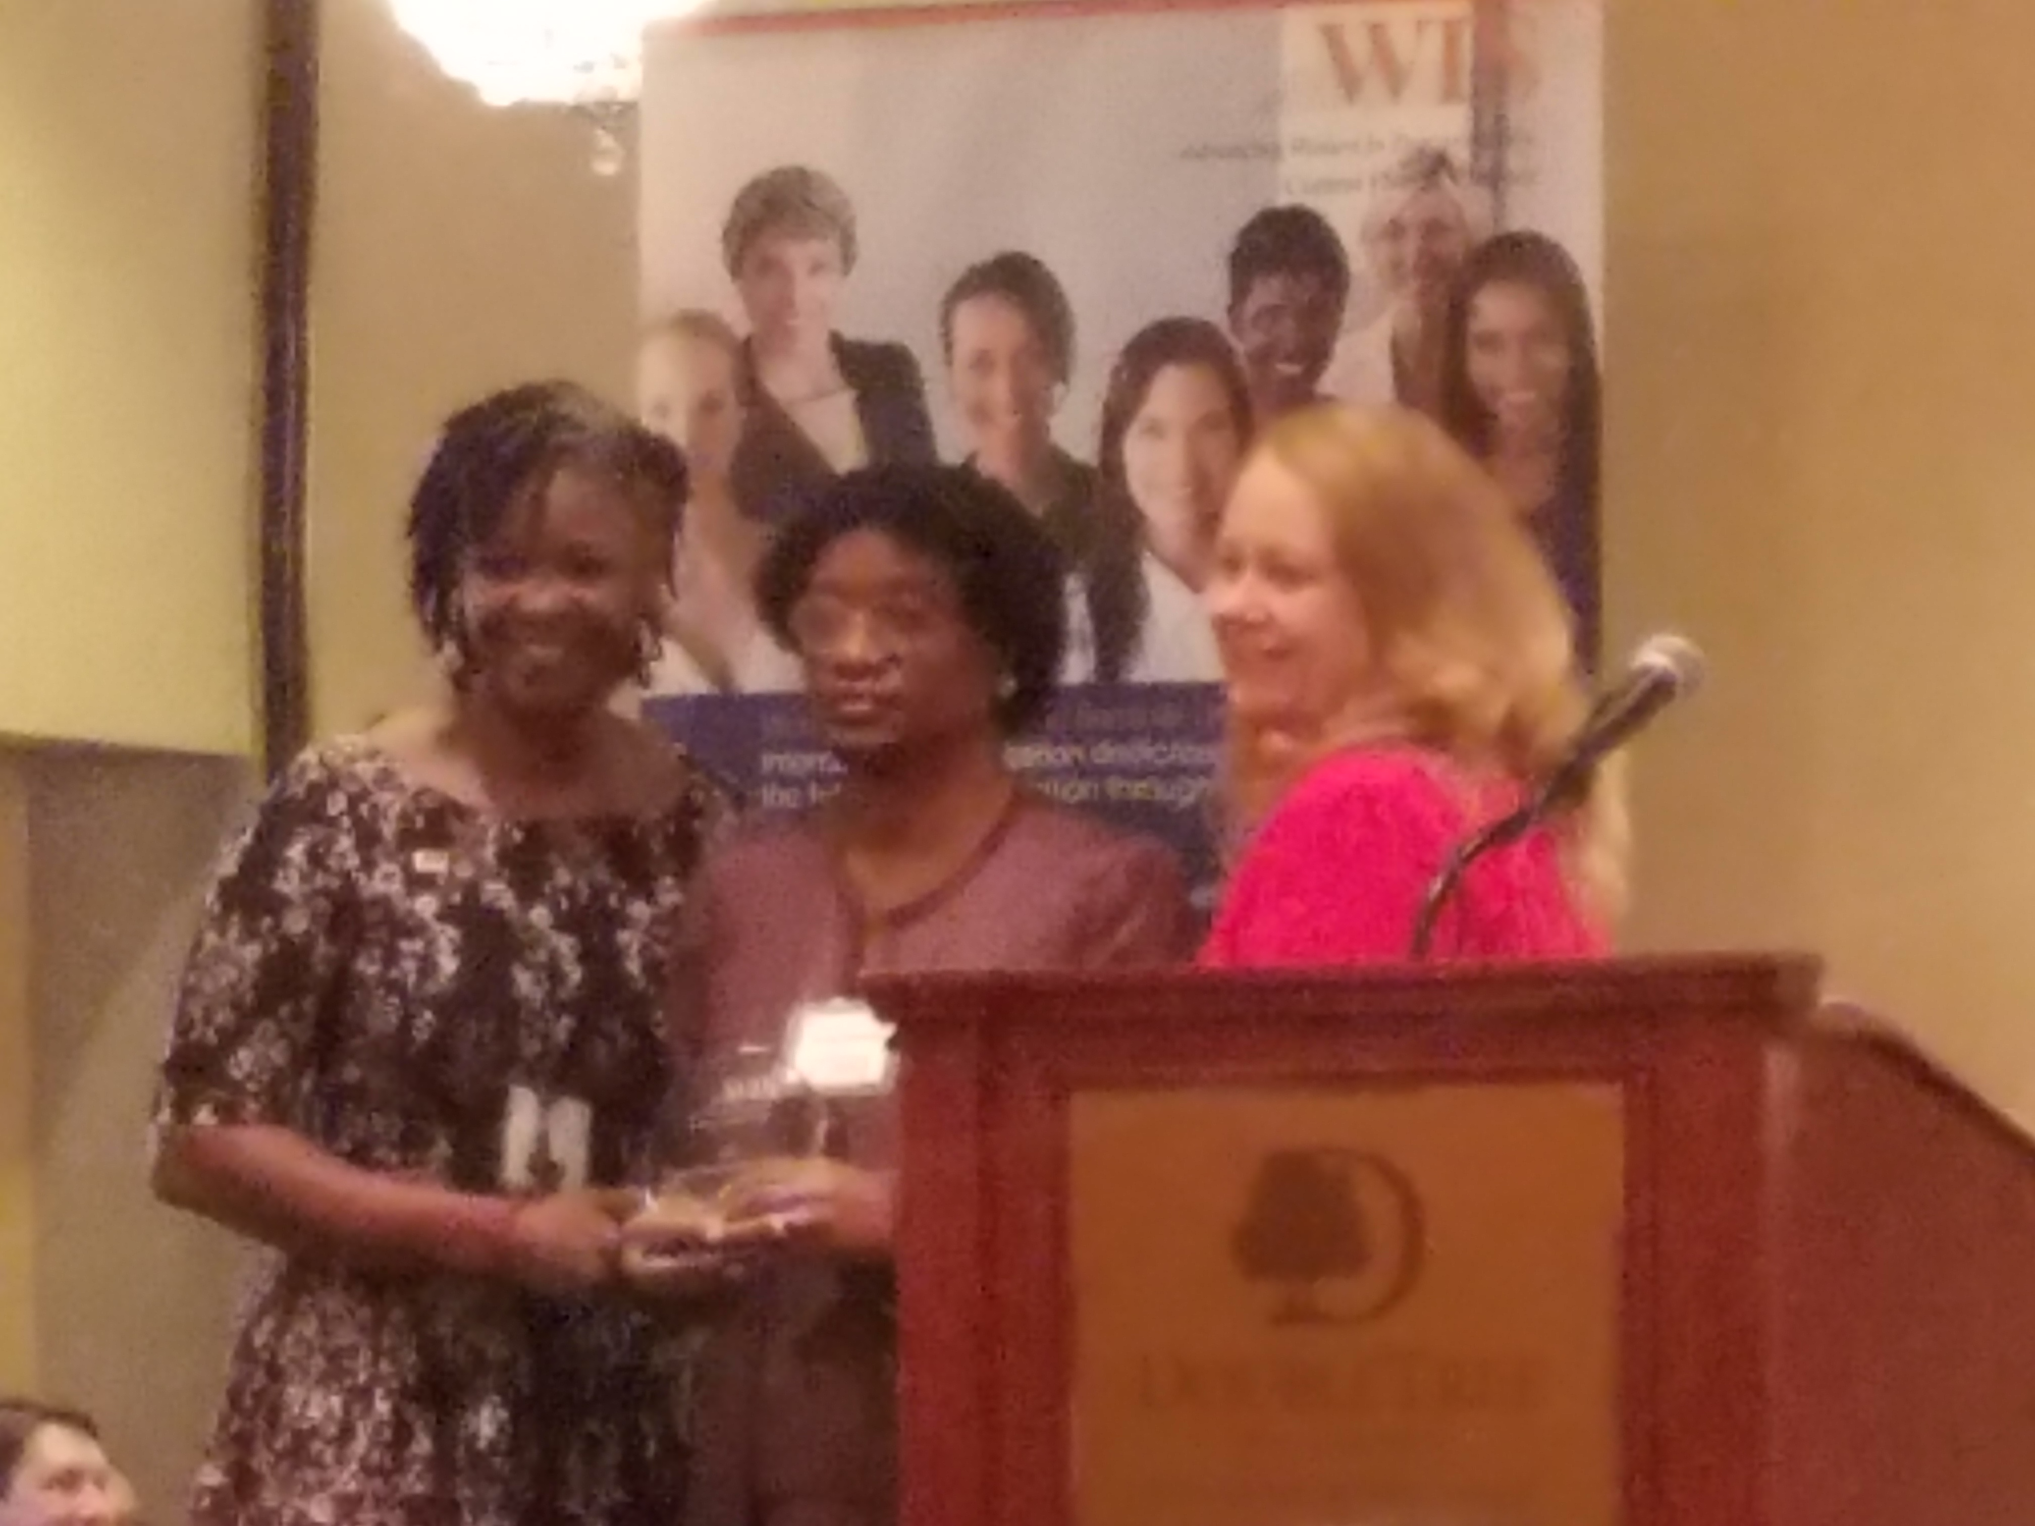
A photo of Marilyn Baldwin receiving an award from WTS of Central Florida. The award is the 2017 Citizen Advocate of the Year. Given on September 21, 2017, at the Doubletree Hotel downtown Orlando. This organization is dedicated to supporting women who work or are studying to be employed in Transportation. The award was given for her work on their local TD Board for many years.

Please contact any of the board with questions, comments, concerns or for general information.
NFBF Board of Director’s Information:
Denise Valkema -President
Phone: 305-972-8529
Email: president@nfbflorida.org

Paul Martinez - 1st Vice President
Phone: 813- 390-5720
Email: paul09ms@gmail.com

Miranda Kilby – 2nd Vice President
Phone: 352- 942-0417
Email: mbkilby@gmail.com

Sylvia Young-Secretary
Phone: 850- 322-5937
Email: secretary@nfbflorida.org

Gloria Mills –Treasurer
Phone: 813-340-9754
Email: glorianfbf@gmail.com

Board Members:
Tekesha Saffold
Phone: 561-707-4799
Email: tnsaffold82@gmail.com

Jorge Hernandez
Phone: 305-877-2311
Email: jeh1065@comcast.net

Camille Tate
Phone: 321 372-4899
Email: Yankiecat@gmail.com

Rafael Fernandez
Phone: 305-903-6299
Email: rafael.fernandez0617@gmail.com
Editor: Sylvia Young
To have something posted in the NFBF Newsletter please submit it to the editor, Sylvia young at secretary@nfbflorida.org by the 15th of each odd month.

