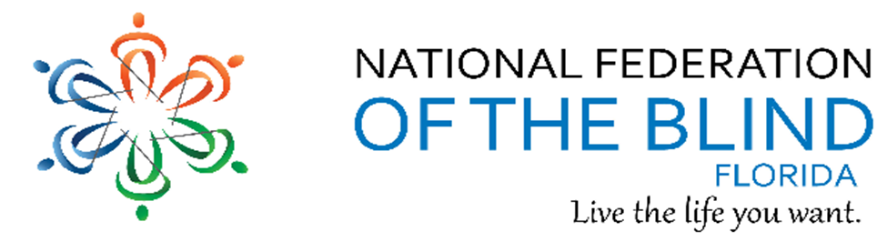BREAKING NEWS
Newsletter
Issue 11 January/February 2018
President’s note:
Greetings Federation Family,
Many thanks to all of you for your hard work and active participation to support your local, state and national organization.
Find us on twitter and FB @nfbflorida.
Denise Valkema, President NFB OF Florida
president@nfbflorida.org
Facebook & Twitter @nfbflorida
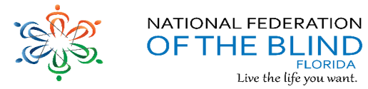
We are filled with hope, energy and love by participating in the National Federation of the Blind. Every day we work together to help blind people live the lives they want.

Birthdays & Celebrations:
The NFBF would like to celebrate:
Birthdays:
January:
Bertha Alexander - Miami
Lorna Gray – Miami
Reginald Howard – Gainesville
James Johnson - Statewide
Betty Mack – Gainesville
Paul Martinez - Statewide
Tyrone McCleod – Tallahassee
February:
Ineko Gary’s - Tampa
Anniversaries:
Marion and Richard DeBusk - February Anniversary – Gainesville

Announcements and Comments:
NFB President Receives Automotive Innovation Award
Baltimore, Maryland (January 22, 2018): Mark A. Riccobono, President of the National Federation of the Blind, has received one of the inaugural Autos2050SM awards. The awards are being presented by the Auto Alliance and the Alliance for Transportation Innovation.
President Riccobono is among twelve state and national political leaders and automotive innovators who will be honored at a dinner and awards presentation in Washington, DC on January 24. The new awards and dinner are part of the larger Autos2050SM event.
On October 25, 2017, the National Federation of the Blind and the Auto Alliance hosted a first-of-its-kind gathering of consumers with disabilities, auto representatives, ride-sharing providers, and policymakers. The purpose of the gathering was to discuss the advances, challenges, and path forward for autonomous vehicle development. It was a key step in the ongoing conversation about how autonomous vehicles can be developed and deployed safely, while considering the needs of the 57 million Americans with disabilities.
On January 29, 2011, President Riccobono became the first blind individual to operate a vehicle independently. He navigated a course at Daytona International Speedway as a demonstration of how technology can allow the blind to drive.
As much as I appreciate the honor of this award, its significance is greater than recognizing the National Federation of the Blind, President Riccobono said. It is also a sign that leaders in the automobile industry recognize the importance of incorporating the input of the blind as the next generation of automotive technology is designed. This gives us hope that new autonomous vehicles will provide a level of mobility and independence that the blind have never experienced before, enhancing our ability to live the lives we want.
"The Autos2050 Driving Innovation Awards are designed to honor those who have made significant contributions over the past year, said Mitch Bainwol, president and CEO, Auto Alliance. Mark and the NFB have been tireless and effective advocates for the needs of the entire disability community in the ongoing national debate around the development of autonomous vehicles.

National Federation of the Blind Statement on Delta’s New Service Animal Policy
Baltimore, Maryland: (January 23, 2018): The National Federation of the Blind stated the following with regard to the new service and support animal policy announced by Delta Air Lines on January 19:
We are deeply concerned that Delta Air Lines has taken this action without consulting the National Federation of the Blind, our division the National Association of Guide Dog Users, or any other democratically elected representative of blind Americans. Blind people have safely and successfully used guide dogs for decades, but this policy fails to make a clear or practical distinction among guide dogs, other “service and support animals” (as Delta puts it), and pets. Onerous restrictions on guide dog handlers do not resolve anything and violate the principle of equal access for passengers with disabilities. Furthermore, we believe that elements of Delta’s policy, as currently articulated, violate the Air Carrier Access Act.
We are particularly troubled by the requirement that guide dog users submit paperwork to Delta forty-eight hours before flying. Travelers without guide dogs are not required to plan their travel forty-eight hours in advance. Furthermore, guide dog users will no longer be able to fly Delta in family, medical, or other emergencies. We believe that this forty-eight-hour requirement is both unnecessary and unlawful.
We are asking for an urgent meeting with Delta and stand ready to work with it and other airlines to craft fair and reasonable policies to address the concerns of air carriers, their personnel, and their passengers, without imposing undue, unsupported, and unlawful hardships on guide dog users. Contact Chris Danielsen, Director of Public Relations for more information at (410) 659-9314, extension 2330; (410) 262-1281 (Cell); cdanielsen@nfb.org

STATE CONVENTION
The Tampa Chapter and Suncoast Chapter are working diligently in planning an awesome state convention. We welcome all ideas for guest speakers, workshops, and extra activities. We encourage everyone to attend the next Events Committee call to learn more about our state convention.
It will be held over Memorial Day Weekend, May 25-28, 2018 at Hilton Tampa Airport Westshore, 2225 North Lois Avenue, Tampa, FL 33607. To make your room reservations, please call the Hilton Tampa Airport Westshore at 813-877-6688. When calling, ask for the National Federation of the Blind of Florida Convention room rate (code NFB) of $104.00 per night. Rooms are reserved on a first-come first-served basis. Your room reservation must be made by May 5, 2018 to guarantee our special hotel rate. It pays to pre-register! Prior to convention the registration fee is $20.00, and the banquet tickets are $40.00 each. The registration and the banquet fee will each increase by $5.00 on Monday, May 7, 2018. So, it is important that we receive your payment by that date to qualify for the special registration and banquet package discount. Don't wait, send your Convention Registration in today! If you have questions, please feel free to contact NFBF Treasurer Gloria Mills Hicks at: treasurer@nfbflorida.org or by calling 1-866-342-5080 or e-mail me at president@ nfbflorida.org.

NATIONAL CONVENTION
The National Federation of the Blind will hold its annual National Convention for the final time in Florida, during the week of July 3-8, 2018. The convention will be at the Rosen Shingle Creek Resort in Orlando, FL. The 2018 room rates are singles and doubles, $88; and triples and quads, $93. In addition to the room rates there will be a tax, which at present is 12.5 percent. No charge will be made for children under seventeen in the room with parents if no extra bed is requested. Please note that the hotel is a no-smoking facility.
Call for your reservations at (866) 996-6338 or you may also write directly to the Rosen Shingle Creek, 9939 Universal Boulevard, Orlando, Florida 32819-9357. The hotel will want a deposit of $100 for each room and will want a credit card number or a personal check. If you use a credit card, the deposit will be charged against your card immediately, just as would be the case with a $100 check. If a reservation is cancelled before Friday, June 1, 2018, half of the deposit will be returned. Otherwise refunds will not be made. Preregister for the convention on the NFB website at www.nfb.org as soon as possible.

The National Federation of the Blind, FL Book Club/Discussion Group is looking for submissions for discussion. We are focusing on speeches and other printed materials about the NFB, its history and philosophy. At this time, we are asking for speeches given by our past Presidents. Please send submissions to Camille Tate at email address: ctate2076@att.net
Our next meeting will be Thursday, February 22nd, at 8 p.m. The item for discussion will be released in time for all to read it. Please have your February submissions to me by Monday, February 12, so it can be distributed to the rest of the list. I would also like to thank everyone who attended our January 25th discussion and made our inaugural meeting a success! Sincerely, Camille Tate

The Florida Rehabilitation Council for the Blind and The Division of Blind Services announces the following Meeting and Public Forum:
Meeting Dates: February 6, 2018; Time: 8:30 a.m. – 3:30 p.m. and February 7, 2018; Time: 9:00 a.m. – 10:30 a.m.
Public Forum Date: February 6, 2018; Time: 4:30 p.m. – 6:00 p.m.
Meeting Location: Embassy Suites, 1100 SE 17th Street, Fort Lauderdale, Florida 33316
Invited Speakers: Local Division of Blind Services District Administrator; Lighthouse of Broward County, Inc. Representative; Local Paratransit Representative; Public Comments will be heard immediately following the presentations.
Attend in Person - Sign in Cards will be Available Outside the Entrance to the Meeting Room for Anyone Wishing to Speak. Or Participate by Telephone by calling 1(888) 670-3525; Passcode 1242528392#
For more information, please contact Selena Sickler, (850) 245-0329 or Email: Selena.Sickler@dbs.fldoe.org.

From President Mark Riccobono:
Dear Friends:
We need your help to make sure that the clock is not turned back for blind rehabilitation consumers. The Association for the Education and Rehabilitation of the Blind and Visually Impaired (AER) announced at the end of the summer last year that it was taking over the agency accreditation program formerly administered by the National Accreditation Council for Blind and Low Vision Services (NAC). This would undo the tremendous progress that has been made in allowing the blind to determine our own destinies and control the programs that directly influence us.
The former NAC accreditation program did not consider, or serve the needs of, blind people and was dropped by most agencies. While we support high standards and certain accreditations, as described in this Braille Monitor article by Dr. Edward Bell, the NAC program was based on low expectations of blind people and other flawed principles.
NAC represents the way the world was; the National Federation of the Blind represents the world of today and the future. We demand a say in the programs that serve us; we demand to be the ones who evaluate them. NAC would turn back the clock, but we live in the present and are actively using our time to shape the future.
We are asking each of you reading this message to do two things: first, read this article from the January issue of the Braille Monitor, written by NFB President Mark Riccobono. Next, take one or more of the actions that President Riccobono outlines at the end of the article to let AER know that blind people will not stand for the revival of NAC.
It is time, once and for all, to say #GoodbyeNAC. Help us put the past behind us and continue building a future where the blind have a say in the lives we will live.
Sincerely, Mark A. Riccobono, President, National Federation of the blind

Letter from The National Office
Greetings fellow Federationists!
I hope and trust that you all had a wonderful holiday season.
President Riccobono has asked us to prioritize a number of important initiatives in 2018. I am writing today to share with you that the National Federation of the Blind is jump starting its work aimed at addressing the critical issue of accessibility and medical technology and devices. Although this will be coordinated from the NFB Jernigan Institute, it will require the participation and collaboration of Federationists around the country.
As far too many of you know all too well, the lack of accessibility when it comes to vital medical equipment can be inconvenient at best but dangerous and risky in many cases. We are therefore creating the Accessible Medical Technology Working Group (AMT-WG), which will be tasked with investigating concerns, devising strategies and making recommendations to President Riccobono.
We will need your help as we get started. In order to focus our work and direct our energies appropriately, we are requesting feedback from you that will let us know what issues are being encountered as a result of inaccessible medical technologies and devices. You do not need to share any personal or private information; we are only looking for the names of devices and technologies that pose accessibility challenges, that way we can channel our attention to where it is needed most. Please be sure to be specific about what aspects of the device make them less accessible. We would also appreciate you letting us know about any medical technology or devices that are accessible, so we can refer to those as positive examples of how accessibility can be done right in this space.
If you have any feedback to share or ideas as to what types of medical technologies and devices need to be a part of this initiative, please send your responses to Eric Duffy at eduffy@nfb.org and Dylan Hedtler-Gaudette at dhedtler-gaudette@nfb.org.
Thank you all for your help as we get this project started. Your contributions will be invaluable, and we look forward to making progress together in the area of accessible medical technology in 2018! Sincerely, Eric Duffy, Director of Access Technology, Dylan Hedtler-Gaudette, Government Affairs Specialist

Link City: Here are some important links that may be of interest.
NFB: https://nfb.org/
NFBF: http://nfbflorida.org/
February Presidential release: http://bit.ly/2nxgDpv

Legislative Updates:
As our delegates to Washington Seminar return from D.C., the Legislative Committee will again turn to our other legislative priorities. We would like to thank all of you who contacted your Congressmen/women and Senators regarding the below legislative priorities that are the focus of our National agenda for 2018:
• Accessible Instructional Materials in Higher Education (AIM Hi) Act: H.R. 1772, S 2138
• Access Technology Affordability Act (ATAA): H.R. 1734, S. 732
• ADA Education and Reform Act of 2017: H.R. 620
• Marrakesh Treaty
As we move forward in 2018, the committee will explore other work to ensure the blind and low vision continue to expand and enjoy our independence. Our next meeting will be announced on the Florida List as the date draws near. Join us and be part of our effort to live the life we want.

Technology: Tips & Tricks
Apple Tips and Tricks from Camille Tate
I recently found myself wanting to delete some unused apps from my iPhone. I did what any self-respecting person would do and went to Google Search. To my surprise, the only instructions I could find (I only looked through 10 pages of search results), told me to open the app and click on the “X” in the upper right corner. This would be easy to do if I could actually see the screen and find the mysterious “X” button. Unfortunately, there were no instructions when you are blind and using voiceover. You can’t ask Siri to do it for you.
Quite by accident, I discovered the solution. I wanted to scroll to the next page of apps and accidentally swiped with one finger. Voiceover said, “edit mode.” I decided to play around with it. Here’s how you can delete apps using voiceover.
• Swipe up or down with one finger on the page with the app you want to delete.
• When voiceover says, “edit mode”, double tap anywhere on the screen. This is important. If you don’t double tap first, you will have to do step 1 again.
• Slide your finger to the app you want to delete, then swipe up or down until you hear “delete app”. Again, this is important; you do not want to delete the wrong app.
• Double tap. An alert will pop up to tell you that if you delete the app, you will lose any and all data associated with the app.
• Double tap on Ok.
• If you are finished deleting apps, swipe up or down until you here “finish editing” or “stop editing”. This will take you out of edit mode.
For multiple apps you want to delete, repeat the above steps, except the last one. If you accidentally delete an app you wanted, you can always download it again from the App Store.

Inspiration Conner:
“If there is one thing I’ve learned in life, it is to fight. Fight for what’s right. Fight for what you believe in and what is important to you. But most importantly, fight for the ones you love and never forget to tell anyone how much they mean to your while they’re still alive.” ― Writer Unknown
Chapter, Division, and Committee updates:
Greater Broward Chapter: Our meetings are held the second Saturday of each month from 10:30 a.m. until 12:30 p.m. at the Westfield Broward Mall, 8000 W. Broward Blvd., Plantation, FL 33312; inside the Plantation Police Outreach Center North side of the Mall.

Central Florida Chapter: Sherri Brun, President; Please like us on Facebook at: https://www.facebook.com/groups/410985858949160. We meet the third Saturday of each month from 11:00am to 1:00pm at Lighthouse Central Florida, 215 East New Hampshire Street, Orlando, Florida 32804.

Greater Daytona Beach Chapter: Joshua Espinal, President, Phone: 407-534-0160, Email Joshua.espinal@everest.edu. We meet the fourth Saturday of the month 11:30am to 1:30pm at TGI Friday's, 24 Ocean Shore Blvd., Ormond Beach FL 32176. Follow Us on Facebook: www.facebook.com/nfbdaytona.

Gainesville Chapter: Judith Hamilton, President; Phone: 352-373-7806, Email: gainesville_nfb@earthlink.net. The Gainesville Chapter welcomes you to our monthly chapter meetings. Meetings are held the second Saturday of the month from 2:00PM to 4:00PM. For additional meeting information or schedule changes, please contact Judy Hamilton, Chapter President. Chapter members celebrated the holidays and are looking forward to 2018 with love, hope, and celebration with our NFB Florida family at state convention in May.

Greater Jacksonville Chapter: Marita Winston, President; Phone: 904-323–8597, Email: marita.winston60@gmail.com. Please join us if you are in the area. Upcoming activities:

Greater Miami Dade Chapter Jorge Hernandez – President; Phone: 305-877-2311; Email: jeh1065@comcast.net. Our meetings are held on the third Thursday of each month. Location: Denny's Restaurant, 5825 N. W. 36 Street, Miami, FL. The Miami-Dade Chapter will commence the fundraiser “Worlds Famous Chocolate” to raise funds for State Convention. The new members are eager to participate at their first State Convention.

Melbourne - Space Coast Chapter: Camille Tate, President; Phone: 321 372-4899; Email: ctate20176@att.net Facebook: www.facebook.com/nfbmelbourne. We meet on the second Saturday of each month at The Fountains, 4451 Stack Blvd, Melbourne, FL 32901 from 9:30 a.m.-12:00 p.m. Next meeting date is February 10th. Please call Camille Tate, President with questions.

Palm Beach Chapter: Tekesha Saffold, President; 561-707-4799; Email: tnsaffold82@gmail.com. We have monthly meetings on the second Saturday of every month at 4746 North Congress Avenue, Boynton Beach, FL 33425.

Polk Chapter: Joe King, President: Phone: 863-293-5648; Email: joenkitty@earthlink.net. Our meetings are held the second Saturday of the month at: Winter Haven Manor, 140 Avenue A S.W., Winter Haven, Florida, at 10:00am-12:00pm.

FL State Wide Chapter: Paul Martinez, President; Phone: 813-390-5720; Email: nfbf.statewide@gmail.com. The State-Wide Chapter invites you to join us on our conference call on the third Sunday of every month at 8:00pm. This chapter was designed for those who do not have a local chapter or for some reason cannot get to their local chapter for any given reason. The chapter is excited to celebrate our 5th year of existence. We are collecting membership dues for the year and will hold elections in February for the following positions: president, Treasurer, board 1 and board 3. Each of those positions will be for 2 years. There will also be a special election for vice president with a 1-year term. We invite you to come and join us and learn more about the Florida State Wide Chapter of the National Federation of the Blind.

Suncoast Chapter: Lauren Blum, President; Phone: 352-584-0795; Email: laurenblum79@gmail.com. Meetings are held on the second Saturday of each month from 1:30 pm to 3:30 pm at IHOP,3660 Commercial Way, Spring Hill, FL 34606.

Tallahassee Chapter: Jada Christie, President; Phone: 850-766-9378 Email: emeraldpink15@gmail.com. We meet the 1st Monday of each month and the Lighthouse of the Big Bend, Tallahassee, FL 32303. We held elections in January and the board stands as before. Congratulations to our awesome leaders.

Tampa Chapter: Miranda Kilby, President; Phone: 352-942-0417; Email: NFBF.Tampa@gmail.com. Join us the fourth Saturday of every month. The chapter is in the process of raising funds for state and national conventions, and already have four spirit nights planned out with Beef O Brady’s. The chapter will be holding elections for the complete board in February. We look forward in 2018 and thank those who have made 2017 successful great year for the Tampa Bay Chapter.

Treasure Coast Chapter: Tim Edwards, President; Phone: 630-432-5090; Email: tred34990@gmail.com. Come join the Treasure Coast Chapter of National Federation of the Blind for its monthly meeting on Saturday February 10, 2018, from 10 am till noon at WQCS Radio Station @ IRSC, 3209 Virginia Avenue, Fort Pierce. Our speaker this month will be Roberta Cook. Roberta is a member of our Chapter. Please RSVP to Tim Edwards, President of the Treasure Coast Chapter, at 630-432-5090 tel:630-432-5090 or you can email Tim at tred34990@gmail.com mailto:tred34990@gmail.com. Mark your calendar for upcoming meetings and events: March 10th – Elections; March 10th - Rosemary Mulero from the Lighthouse for the Blind of the Palm Beaches; April 14th; May 12th; June 9th.

Florida Association of Guide Dog Users (FLAGDU): Sherrill O'Brien, Division President; flagdu@nfbflorida.org

Deaf-Blind Division: Alicia Betancourt, Interim President; Phone: 386-589-7324; Email: licib85@gmail.com. The FL Deaf-Blind division meets by teleconference call on the second Tuesday of every month at 8:00pm. Call in number is 515-604-9853, Access code: 997037. People with hearing and vision loss represent a unique segment of Florida’s population and we work to promote greater understanding of this dual disability. If you are interested in actively participating and learning more about this division, please contact Alicia Betancourt.

Florida Organization of Parents of Blind Children (FOPBC): The Parents Division is being reorganized by Kimberly Banks, Email: kimberlybanks1984@gmail.com

Florida Association of Blind Students: The FABS invites any high school or college student to attend our conference calls on the third Sunday of every month at 6:00pm. For further information, contact the president, Joseph Chica at 305-333-10335 jhc102@miami.edu. To call into our meetings use conference number 641-715-3274 and access code 401665.

Committee to Empower Underserved Populations: Marilyn Baldwin, Chairman, 8427 Lainie Lane, Orlando, Florida 32818, 407-293-0565, CommMDB@aol.com. Next meeting is December 5, 2017 at 8 pm. Everyone is encouraged to attend or have at least one representative from your chapter or division. The Conference call number is (712) 775-7031; Code 938047311

Communication Committee: Miranda Kilby, Chairman; Phone: 352-942-0417; Email: mbkilby@gmail.com. The committee is excited to plan and strategize for new and creative ideas for 2018. We are working on meeting goals by state convention with Newsline, Face Book, and Twitter.

THE EVENTS COMMITTEE: Gloria Mills-Hicks, Chairman; Phone: 813-340-9754; Email: glorianfbf@gmail.com. This is the committee that has the responsibility for generating ideas and producing the groundwork for the upcoming NFBF State Convention, which will take place over the Memorial Day Weekend, later this year. If you have ideas for this convention, or just want to help make the convention a success, you should call in. The phone number for the call is 712-775-7031; Access Code is 488500#. Stay tuned to the list-sever for the next call.

Fundraising committee: The committee met in January and strategized several ideas for our upcoming fundraiser. I thank everyone who called in and gave their ideas. We are pleased to announce The Amazing Trio Bundle Raffle. The 1st prize winner will win an I Pad Pro or the cash value of $800, the 2nd prize is a $500 Uber or lift gift card or the cash value, and the 3rd prize winner will win a $200 travel voucher or the cash value. Each ticket will be $5, and the drawling will take place at our national convention on Sunday, July 8th.
Also, the NFB lapel pins are avaible for purchase for only $5 each. The lapel pins spell out NFB all in capital letters. The N is blue, the F is orange and the B is green, with a boarder of silver around the letters. Quantity is limited, so contact Paul Martinez, Fundraising chairman at 813- 390-5720 or Email: paul09ms@gmail.com today and purchase our one of a kind limited supply lapel pins.

NFB411: Our last topic was on Networking and building relationships with Kathrine Webster, President of the national Association of Blind Students. Did you miss the call? Check out the recording by dialing, 712-775-7029. Then use access code 938047311, reference number 32. The next call is in the planning process and all ideas are welcomed.

Scholarship Committee: The 2018 NFBF Student Scholarship will be released on February 1st. We ask everyone to share our scholarship with every blind student in the state of Florida. The application along with the rules and guidelines will be posted on our Florida List Serve and on the web at nfbflorida.org.

Senior Concerns Committee: Gloria Mills-Hicks, Chairman; Phone: 813-340-9754; Email: glorianfbf@gmail.com. The next meeting of the NFBF will take place Thursday, February 1, 2018, at 8:00 PM. The phone number for the call is 712-775-7031 The Code is 488500#. We want to continue planning a Senior Retreat, to bring more seniors into the NFBF. There will be other topics of discussion. Remember that you need not be a senior to take part.

The National Association of Blind Veterans: Dwight Sayer, President; 321-948-1466; Email: president@nabv.org; PO Box 784957, Winter Garden, Florida 34778.

Photo Gallery:
Picture of Washington Seminar delegates working on the hill. From left to right Sylvia Young, Congressman Yoho – 3rd District, Jada Christie and Russ Davis.
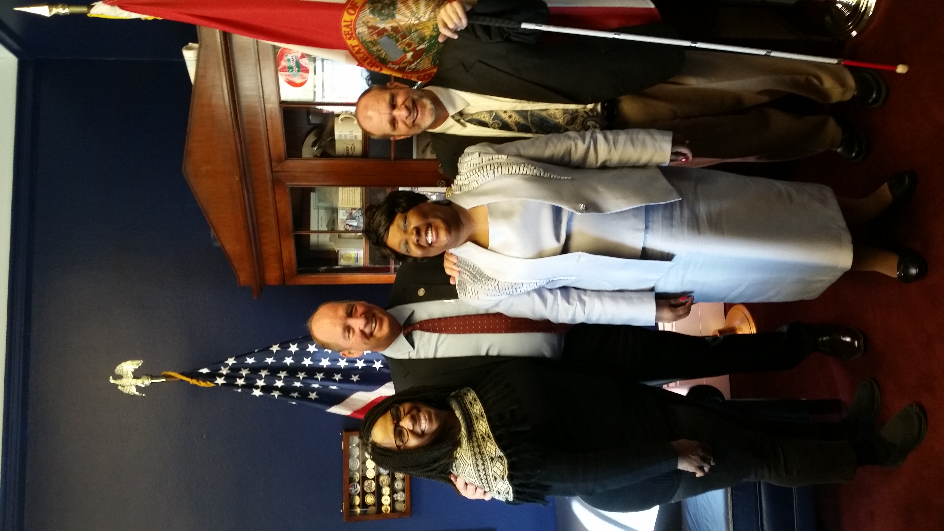

Please contact any of the board with questions, comments, concerns or for general information.
NFBF Board of Director’s Information:
Denise Valkema -President
Phone: 305-972-8529
Email: president@nfbflorida.org

Paul Martinez - 1st Vice President
Phone: 813- 390-5720
Email: paul09ms@gmail.com

Miranda Kilby – 2nd Vice President
Phone: 352- 942-0417
Email: mbkilby@gmail.com

Sylvia Young-Secretary
Phone: 850- 322-5937
Email: secretary@nfbflorida.org

Gloria Mills –Treasurer
Phone: 813-340-9754
Email: glorianfbf@gmail.com

Board Members:
Tekesha Saffold
Phone: 561-707-4799
Email: tnsaffold82@gmail.com

Jorge Hernandez
Phone: 305-877-2311
Email: jeh1065@comcast.net

Camille Tate
Phone: 321-372-4899
Email: ctate20176@att.net

Rafael Fernandez
Phone: 305-903-6299
Email: rafael.fernandez0617@gmail.com
Editor: Sylvia Young
To have something posted in the NFBF Newsletter please submit it to the editor, Sylvia young at secretary@nfbflorida.org by the 15th of each odd month.

