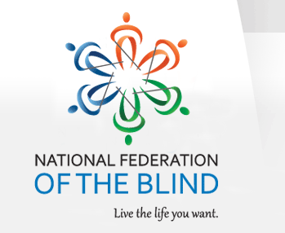

The National Federation of the Blind of Florida is now accepting student scholarship applications for 2023 in recognition of their achievements and professional aspirations. Recipients will receive their scholarships at the 2023 Annual State convention scheduled for the weekend of Friday, October 6th through Sunday, October 8th in Tampa, Florida.
Qualified high school seniors and college students must complete the scholarship application form in MS word format, write a 500-word essay, provide two letters of recommendation, and submit their academic transcripts.
All documentation must be return to:
Jorge Hernandez, Chair
NFBF Scholarship Committee
Email: scholarships@nfbflorida.org
Cell Phone: 786-220-1595

The National Federation of the Blind of Florida will be awarding three scholarships, each in the amount of $1,500 at the National Federation of the Blind of Florida annual convention banquet on Sunday evening, October 8, 2023.
Completed applications are due no later than August 10, 2023, at 11:59 p.m.
For your convenience, the scholarship application, scholarship checklist, and scholarship guidelines are attached to this correspondence.
For more information you can contact the scholarship chair, Jorge Hernandez via Email or mobile number located in this correspondence.
Sincerely,

Jorge Hernandez, Scholarship Chair
1st Vice president
National Federation of the blind of Florida
Board of Directors

